Database Design and Applications (S2-21)

- Event Management System project

## Team details

|  |  |
| --- | --- |
| 1 | Karthik G [[2021mt13076@wilp.bits-pilani.ac.in](mailto:2021mt13076@wilp.bits-pilani.ac.in)] |
| 2 | Gopal Raj M[[2020ht66057@wilp.bits-pilani.ac.in](mailto:2020ht66057@wilp.bits-pilani.ac.in)] |
| 3 | Avinash Vasudeo H[[2021ht66003@wilp.bits-pilani.ac.in](mailto:2021ht66003@wilp.bits-pilani.ac.in)] |
| 4 | Harikrishnan B[2021mt93339@wilp.bits-pilani.ac.in](mailto:2021mt93339@wilp.bits-pilani.ac.in) |
| 5 | Greeshma G K[[2021mt13041@wilp.bits-pilani.ac.in](mailto:2021mt13041@wilp.bits-pilani.ac.in)] |
| 6 | Hammad Al Hannan[[2021mt13178@wilp.bits-pilani.ac.in](mailto:2021mt13178@wilp.bits-pilani.ac.in)] |
| 7 | Prakash Gudapati[[2021mt13355@wilp.bits-pilani.ac.in](mailto:2021mt13355@wilp.bits-pilani.ac.in)] |
| 8 | Hannah D P [[2021mt13247@wilp.bits-pilani.ac.in](mailto:2021mt13247@wilp.bits-pilani.ac.in)] |

## Project Description

The aim of this project is to create a robust database for an event management system. This system aims to store information related employees, clients, suppliers, events, and payments. The Database is designed such that it’s easy for clients to choose events based on their budget and helps the vent managers to co-ordinate with corresponding suppliers. We have designed the database using all the design concepts we have learnt so far.

### Who will be the users?

|  |  |
| --- | --- |
| **User** | **Role** |
| Employee | A person who works for the company which uses the event management system. |
| Client | A person who makes use of the services provider by the company which uses the event management system. |
| Supplier | A person who provides goods used for the events. |
| Admin user | A person who has backend access to the event management system. |

### What are the benefits of this application?

This Project is especially designed for event managers. The event manager will be able to feed in keep record and project reports of his work. It provides a user-friendly approach for handling all the services. Some of the important features of the project are Events gives information about all the requirements of services and products of the event being organized. In this database manager will get every information about every event which is done, and which are going on in future.

### Functions and Features

An **Employee,** can create new orders for potential clients, generate sales reports, order for supplies, keep track of all arrangements.

A **client** can order for new events, pay for their orders.

An **admin,** can create new employee records, can modify/cancel existing orders, add new suppliers.

## Database Design

**Entities**

Client, Event Manager, Event admin. Supplier, Event, Invoice, Payment, Goods.

**Attributes:**

Client: User ID, Password, R- Password, Name, Address, Phone no, city, state Zip code, Email ID.

Event Manager: unique ID and a password

Employee: UID, password, role.

Supplier: Supplier Name, Supplier ID, Phone no, Email ID, address.

Event: Event type, EventId, Event Name.

Order: OrderID, Event ID, total amount, date, order status, Location.

Payment: Transaction ID, payment status, paid amount, balance amount, date.

Goods: ItemID, Name, Cost

**Relationships**:

Client – orders – Create orders

Orders – Event Manager – Takes orders

Event – Event Manager – Manages

Event Manager – Emp – reports

Goods– Supplier – Arranges

Event – Emp – Executes

Order – Payment - Pay

Event – Goods – Required.

### ER Diagram

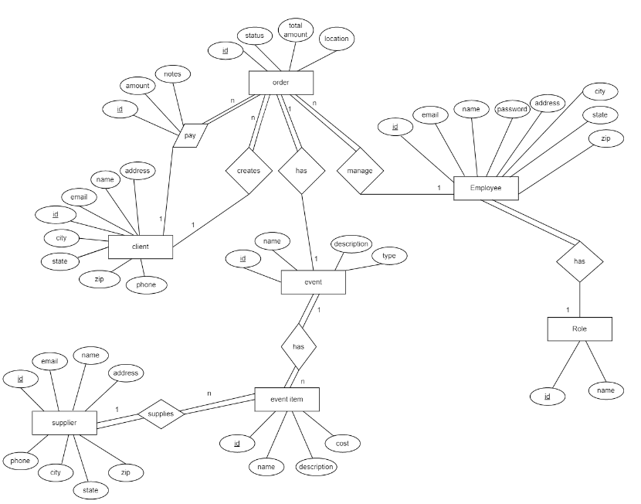

### Object Model



### Relational model

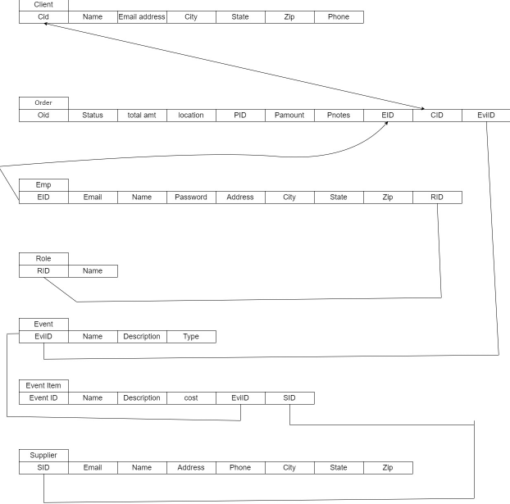

### SQL queries

CREATE DATABASE IF NOT EXISTS `event_management`;

USE `event_management`;

-- MySQL dump 10.13 Distrib 5.6.17, for Win32 (x86)

--

-- Table structure for table `role`

--

DROP TABLE IF EXISTS `role`;

CREATE TABLE `role` (

`id` int NOT NULL AUTO_INCREMENT,

`name` varchar(100) NOT NULL,

`is_active` tinyint NOT NULL,

`is_deleted` tinyint NOT NULL,

`insert_timestamp` timestamp NOT NULL DEFAULT CURRENT_TIMESTAMP,

`update_timestamp` timestamp NOT NULL DEFAULT CURRENT_TIMESTAMP,

PRIMARY KEY (`id`)

) ENGINE=InnoDB DEFAULT CHARSET=utf8mb4 COLLATE=utf8mb4_0900_ai_ci;

-- Table structure for table `employee`

--

DROP TABLE IF EXISTS `employee`;

CREATE TABLE `employee` (

`id` int NOT NULL AUTO_INCREMENT,

`user_role_id` int NOT NULL,

`password` varchar(100) NOT NULL,

`email` varchar(100) CHARACTER SET utf8mb4 COLLATE utf8mb4_0900_ai_ci NOT NULL,

`name` varchar(100) NOT NULL,

`address` varchar(1000) DEFAULT NULL,

`phone` varchar(20) DEFAULT NULL,

`city` varchar(20) DEFAULT NULL,

`state` varchar(20) DEFAULT NULL,

`zip` varchar(20) DEFAULT NULL,

`is_active` tinyint NOT NULL,

`is_deleted` tinyint NOT NULL,

`insert_timestamp` timestamp NOT NULL DEFAULT CURRENT_TIMESTAMP,

`update_timestamp` timestamp NOT NULL DEFAULT CURRENT_TIMESTAMP,

PRIMARY KEY (`id`),

KEY `USER_ROLE_FK_idx` (`user_role_id`),

CONSTRAINT `USER_ROLE_FK` FOREIGN KEY (`user_role_id`) REFERENCES `role` (`id`)

) ENGINE=InnoDB DEFAULT CHARSET=utf8mb4 COLLATE=utf8mb4_0900_ai_ci;

--

-- Table structure for table `client`

--

DROP TABLE IF EXISTS `client`;

CREATE TABLE `client` (

`id` int NOT NULL AUTO_INCREMENT,

`password` varchar(100) NOT NULL,

`email` varchar(100) CHARACTER SET utf8mb4 COLLATE utf8mb4_bin NOT NULL,

`name` varchar(100) NOT NULL,

`address` varchar(1000) DEFAULT NULL,

`phone` varchar(20) DEFAULT NULL,

`city` varchar(20) DEFAULT NULL,

`state` varchar(20) DEFAULT NULL,

`zip` varchar(20) DEFAULT NULL,

`is_active` tinyint NOT NULL,

`is_deleted` tinyint NOT NULL,

`insert_timestamp` timestamp NOT NULL DEFAULT CURRENT_TIMESTAMP,

`update_timestamp` timestamp NOT NULL DEFAULT CURRENT_TIMESTAMP,

PRIMARY KEY (`id`)

) ENGINE=InnoDB DEFAULT CHARSET=utf8mb4 COLLATE=utf8mb4_0900_ai_ci;

--

-- Table structure for table `event_type`

--

DROP TABLE IF EXISTS `event_type`;

CREATE TABLE `event_type` (

`id` int NOT NULL AUTO_INCREMENT,

`name` varchar(50) NOT NULL,

`description` varchar(1000) NOT NULL,

`is_active` tinyint NOT NULL,

`is_deleted` tinyint NOT NULL,

`insert_timestamp` timestamp NOT NULL DEFAULT CURRENT_TIMESTAMP,

`update_timestamp` timestamp NOT NULL DEFAULT CURRENT_TIMESTAMP,

PRIMARY KEY (`id`)

) ENGINE=InnoDB DEFAULT CHARSET=utf8mb4 COLLATE=utf8mb4_0900_ai_ci;

--

-- Table structure for table `event`

--

DROP TABLE IF EXISTS `event`;

CREATE TABLE `event` (

`id` int NOT NULL AUTO_INCREMENT,

`event_type_id` int NOT NULL,

`name` varchar(50) NOT NULL,

`description` varchar(1000) NOT NULL,

`is_active` tinyint NOT NULL,

`is_deleted` tinyint NOT NULL,

`insert_timestamp` timestamp NOT NULL DEFAULT CURRENT_TIMESTAMP,

`update_timestamp` timestamp NOT NULL DEFAULT CURRENT_TIMESTAMP,

PRIMARY KEY (`id`),

KEY `EVENT_TYPE_FK_idx` (`event_type_id`),

CONSTRAINT `EVENT_TYPE_FK` FOREIGN KEY (`event_type_id`) REFERENCES `event_type` (`id`)

) ENGINE=InnoDB DEFAULT CHARSET=utf8mb4 COLLATE=utf8mb4_0900_ai_ci;

--

-- Table structure for table `supplier`

--

DROP TABLE IF EXISTS `supplier`;

CREATE TABLE `supplier` (

`id` int NOT NULL AUTO_INCREMENT,

`email` varchar(100) CHARACTER SET utf8mb4 COLLATE utf8mb4_0900_ai_ci NOT NULL,

`name` varchar(100) NOT NULL,

`address` varchar(1000) DEFAULT NULL,

`phone` varchar(20) DEFAULT NULL,

`city` varchar(20) DEFAULT NULL,

`state` varchar(20) DEFAULT NULL,

`zip` varchar(20) DEFAULT NULL,

`is_active` tinyint NOT NULL,

`is_deleted` tinyint NOT NULL,

`insert_timestamp` timestamp NOT NULL DEFAULT CURRENT_TIMESTAMP,

`update_timestamp` timestamp NOT NULL DEFAULT CURRENT_TIMESTAMP,

PRIMARY KEY (`id`)

) ENGINE=InnoDB DEFAULT CHARSET=utf8mb4 COLLATE=utf8mb4_0900_ai_ci;

--

-- Table structure for table `event_item`

--

DROP TABLE IF EXISTS `event_item`;

CREATE TABLE `event_item` (

`id` int NOT NULL AUTO_INCREMENT,

`event_id` int NOT NULL,

`supplier_id` int NOT NULL,

`name` varchar(50) NOT NULL,

`description` varchar(1000) NOT NULL,

`cost` decimal(10,2) NOT NULL,

`is_active` tinyint NOT NULL,

`is_deleted` tinyint NOT NULL,

`insert_timestamp` timestamp NOT NULL DEFAULT CURRENT_TIMESTAMP,

`update_timestamp` timestamp NOT NULL DEFAULT CURRENT_TIMESTAMP,

PRIMARY KEY (`id`),

KEY `EVENT_FK_idx` (`event_id`),

KEY `SUPPLIER_FK_idx` (`supplier_id`),

CONSTRAINT `EVENT_FK` FOREIGN KEY (`event_id`) REFERENCES `event` (`id`),

CONSTRAINT `SUPPLIER_FK` FOREIGN KEY (`supplier_id`) REFERENCES `supplier` (`id`)

) ENGINE=InnoDB DEFAULT CHARSET=utf8mb4 COLLATE=utf8mb4_0900_ai_ci;

--

-- Table structure for table `order_status`

--

DROP TABLE IF EXISTS `order_status`;

CREATE TABLE `order_status` (

`id` int NOT NULL AUTO_INCREMENT,

`name` varchar(50) NOT NULL,

`description` varchar(1000) NOT NULL,

`is_active` tinyint NOT NULL,

`is_deleted` tinyint NOT NULL,

`insert_timestamp` timestamp NOT NULL DEFAULT CURRENT_TIMESTAMP,

`update_timestamp` timestamp NOT NULL DEFAULT CURRENT_TIMESTAMP,

PRIMARY KEY (`id`)

) ENGINE=InnoDB DEFAULT CHARSET=utf8mb4 COLLATE=utf8mb4_0900_ai_ci;

--

-- Table structure for table `order`

--

DROP TABLE IF EXISTS `order`;

/*!40101 SET @saved_cs_client = @@character_set_client */;

/*!40101 SET character_set_client = utf8 */;

CREATE TABLE `order` (

`id` int NOT NULL AUTO_INCREMENT,

`event_item_id` int NOT NULL,

`status_id` int NOT NULL,

`client_id` int NOT NULL,

`event_manager_id` int NOT NULL,

`event_admin_id` int NOT NULL,

`order_no` varchar(20) NOT NULL,

`total_amount` decimal(10,2) NOT NULL,

`location` varchar(8000) NOT NULL,

`is_deleted` tinyint NOT NULL,

`insert_timestamp` timestamp NOT NULL DEFAULT CURRENT_TIMESTAMP,

`update_timestamp` timestamp NOT NULL DEFAULT CURRENT_TIMESTAMP,

PRIMARY KEY (`id`),

UNIQUE KEY `order_no_UNIQUE` (`order_no`),

KEY `EVENT_ITEM_FK_idx` (`event_item_id`),

KEY `STATUS_FK_idx` (`status_id`),

KEY `CLIENT_FK_idx` (`client_id`),

KEY `EVENT_MANAGER_FK_idx` (`event_manager_id`),

KEY `EVENT_ADMIN_FK_idx` (`event_admin_id`),

CONSTRAINT `CLIENT_FK` FOREIGN KEY (`client_id`) REFERENCES `client` (`id`),

CONSTRAINT `EVENT_ADMIN_FK` FOREIGN KEY (`event_admin_id`) REFERENCES `employee` (`id`),

CONSTRAINT `EVENT_ITEM_FK` FOREIGN KEY (`event_item_id`) REFERENCES `event_item` (`id`),

CONSTRAINT `EVENT_MANAGER_FK` FOREIGN KEY (`event_manager_id`) REFERENCES `employee` (`id`),

CONSTRAINT `STATUS_FK` FOREIGN KEY (`status_id`) REFERENCES `order_status` (`id`)

) ENGINE=InnoDB DEFAULT CHARSET=utf8mb4 COLLATE=utf8mb4_0900_ai_ci;

--

-- Table structure for table `payment_type`

--

DROP TABLE IF EXISTS `payment_type`;

CREATE TABLE `payment_type` (

`id` int NOT NULL AUTO_INCREMENT,

`name` varchar(50) NOT NULL,

`description` varchar(1000) NOT NULL,

`is_active` tinyint NOT NULL,

`is_deleted` tinyint NOT NULL,

`insert_timestamp` timestamp NOT NULL DEFAULT CURRENT_TIMESTAMP,

`update_timestamp` timestamp NOT NULL DEFAULT CURRENT_TIMESTAMP,

PRIMARY KEY (`id`)

) ENGINE=InnoDB DEFAULT CHARSET=utf8mb4 COLLATE=utf8mb4_0900_ai_ci;

--

-- Table structure for table `payment`

--

DROP TABLE IF EXISTS `payment`;

CREATE TABLE `payment` (

`id` int NOT NULL AUTO_INCREMENT,

`payment_type_id` int NOT NULL,

`order_id` int NOT NULL,

`amount` decimal(10,2) NOT NULL,

`note` varchar(4000) DEFAULT NULL,

`is_deleted` tinyint NOT NULL,

`insert_timestamp` timestamp NOT NULL DEFAULT CURRENT_TIMESTAMP,

`update_timestamp` timestamp NOT NULL DEFAULT CURRENT_TIMESTAMP,

PRIMARY KEY (`id`),

KEY `PAYMENT_TYPE_FK_idx` (`payment_type_id`),

KEY `ORDER_FK_idx` (`order_id`),

CONSTRAINT `ORDER_FK` FOREIGN KEY (`order_id`) REFERENCES `order` (`id`),

CONSTRAINT `PAYMENT_TYPE_FK` FOREIGN KEY (`payment_type_id`) REFERENCES `payment_type` (`id`)

) ENGINE=InnoDB DEFAULT CHARSET=utf8mb4 COLLATE=utf8mb4_0900_ai_ci;

--

-- Role master data

--

INSERT INTO `event_management`.`role` (`id`, `name`, `is_active`, `is_deleted`) VALUES ('1', 'Admin', '1', '0');

INSERT INTO `event_management`.`role` (`id`, `name`, `is_active`, `is_deleted`) VALUES ('2', 'Manager', '1', '0');

INSERT INTO `event_management`.`role` (`id`, `name`, `is_active`, `is_deleted`) VALUES ('3', 'Executive', '1', '0');

--

-- Event type master data

--

INSERT INTO `event_management`.`event_type` (`id`, `name`, `description`, `is_active`, `is_deleted`) VALUES ('1', 'Basic', 'Economy events consept. Events organized with necessry objecs and activities.', '1', '0');

INSERT INTO `event_management`.`event_type` (`id`, `name`, `description`, `is_active`, `is_deleted`) VALUES ('2', 'Medium', 'Average events consept. Events organized with objecs and activities which are commonly available in every normal events of this type.', '1', '0');

INSERT INTO `event_management`.`event_type` (`id`, `name`, `description`, `is_active`, `is_deleted`) VALUES ('3', 'Premium', 'Premium event consept. Event organized with very premium obects and activities.', '1', '0');

--

-- Event master data

--

INSERT INTO `event_management`.`event` (`id`, `event_type_id`, `name`, `description`, `is_active`, `is_deleted`) VALUES ('1', '1', 'Birthday', 'Birthdays are a new start, a fresh beginning and a time to pursue new endeavors with new goals.', '1', '0');

INSERT INTO `event_management`.`event` (`id`, `event_type_id`, `name`, `description`, `is_active`, `is_deleted`) VALUES ('2', '2', 'Birthday', 'Birthdays are a new start, a fresh beginning and a time to pursue new endeavors with new goals.', '1', '0');

INSERT INTO `event_management`.`event` (`id`, `event_type_id`, `name`, `description`, `is_active`, `is_deleted`) VALUES ('3', '3', 'Birthday', 'Birthdays are a new start, a fresh beginning and a time to pursue new endeavors with new goals.', '1', '0');

INSERT INTO `event_management`.`event` (`id`, `event_type_id`, `name`, `description`, `is_active`, `is_deleted`) VALUES ('4', '1', 'Marriage', 'A happy marriage is a long conversation which always seems too short.', '1', '0');

INSERT INTO `event_management`.`event` (`id`, `event_type_id`, `name`, `description`, `is_active`, `is_deleted`) VALUES ('5', '2', 'Marriage', 'A happy marriage is a long conversation which always seems too short.', '1', '0');

INSERT INTO `event_management`.`event` (`id`, `event_type_id`, `name`, `description`, `is_active`, `is_deleted`) VALUES ('6', '3', 'Marriage', 'A happy marriage is a long conversation which always seems too short.', '1', '0');

INSERT INTO `event_management`.`event` (`id`, `event_type_id`, `name`, `description`, `is_active`, `is_deleted`) VALUES ('7', '1', 'Naming ceremony', 'May your child be blessed and protected by God\'s wonderful love. Do celebrate the occation in devine but party way.', '1', '0');

INSERT INTO `event_management`.`event` (`id`, `event_type_id`, `name`, `description`, `is_active`, `is_deleted`) VALUES ('8', '2', 'Naming ceremony', 'May your child be blessed and protected by God\'s wonderful love. Do celebrate the occation in devine but party way.', '1', '0');

INSERT INTO `event_management`.`event` (`id`, `event_type_id`, `name`, `description`, `is_active`, `is_deleted`) VALUES ('9', '3', 'Naming ceremony', 'May your child be blessed and protected by God\'s wonderful love. Do celebrate the occation in devine but party way.', '1', '0');

INSERT INTO `event_management`.`event` (`id`, `event_type_id`, `name`, `description`, `is_active`, `is_deleted`) VALUES ('10', '1', 'Kitty party', 'Every Indian woman likes to host unique kitty parties once in a while. Let us work together to colour the occation', '1', '0');

INSERT INTO `event_management`.`event` (`id`, `event_type_id`, `name`, `description`, `is_active`, `is_deleted`) VALUES ('11', '2', 'Kitty party', 'Every Indian woman likes to host unique kitty parties once in a while. Let us work together to colour the occation', '1', '0');

INSERT INTO `event_management`.`event` (`id`, `event_type_id`, `name`, `description`, `is_active`, `is_deleted`) VALUES ('12', '3', 'Kitty party', 'Every Indian woman likes to host unique kitty parties once in a while. Let us work together to colour the occation', '1', '0');

INSERT INTO `event_management`.`event` (`id`, `event_type_id`, `name`, `description`, `is_active`, `is_deleted`) VALUES ('13', '1', 'Farewell', 'Don’t be dismayed at goodbyes. A farewell is necessary before you can meet again. And meeting again, after moments or lifetimes, is certain for those who are friends. Cheer up!', '1', '0');

INSERT INTO `event_management`.`event` (`id`, `event_type_id`, `name`, `description`, `is_active`, `is_deleted`) VALUES ('14', '2', 'Farewell', 'Don’t be dismayed at goodbyes. A farewell is necessary before you can meet again. And meeting again, after moments or lifetimes, is certain for those who are friends. Cheer up!', '1', '0');

INSERT INTO `event_management`.`event` (`id`, `event_type_id`, `name`, `description`, `is_active`, `is_deleted`) VALUES ('15', '3', 'Farewell', 'Don’t be dismayed at goodbyes. A farewell is necessary before you can meet again. And meeting again, after moments or lifetimes, is certain for those who are friends. Cheer up!', '1', '0');

--

-- Supplier master data

--

INSERT INTO `event_management`.`supplier` (`id`, `email`, `name`, `address`, `phone`, `city`, `state`, `zip`, `is_active`, `is_deleted`) VALUES ('1', 'wedland@gmail.com', 'Wedland', 'Arena Plaza, East fort', '2222222222', 'Trivandrum', 'Kerala', '123456', '1', '0');

INSERT INTO `event_management`.`supplier` (`id`, `email`, `name`, `address`, `phone`, `city`, `state`, `zip`, `is_active`, `is_deleted`) VALUES ('2', 'prettyevents@gmail.com', 'Pretty Events', 'Wed Plaza, Valmiki Nagar', '3333333333', 'Chennair', 'Tamilnadu', '456789', '1', '0');

INSERT INTO `event_management`.`supplier` (`id`, `email`, `name`, `address`, `phone`, `city`, `state`, `zip`, `is_active`, `is_deleted`) VALUES ('3', 'amoulika@gmail.com', 'Amoulika', 'Lalbagh', '4444444444', 'Banglore', 'Karnataka', '321234', '1', '0');

--

-- Event item master data

--

INSERT INTO `event_management`.`event_item` (`event_id`, `supplier_id`, `name`, `cost`, `is_active`, `is_deleted`) VALUES ('1', '2', 'Pretty B\'Day', '30000', '1', '0');

INSERT INTO `event_management`.`event_item` (`event_id`, `supplier_id`, `name`, `cost`, `is_active`, `is_deleted`) VALUES ('2', '2', 'Super B\'day', '50000', '1', '0');

INSERT INTO `event_management`.`event_item` (`event_id`, `supplier_id`, `name`, `cost`, `is_active`, `is_deleted`) VALUES ('3', '3', 'Glorious B\'day', '75000', '1', '0');

INSERT INTO `event_management`.`event_item` (`event_id`, `supplier_id`, `name`, `cost`, `is_active`, `is_deleted`) VALUES ('4', '1', 'Silver Weds', '1200000', '1', '0');

INSERT INTO `event_management`.`event_item` (`event_id`, `supplier_id`, `name`, `cost`, `is_active`, `is_deleted`) VALUES ('5', '1', 'Glory Weds', '2000000', '1', '0');

INSERT INTO `event_management`.`event_item` (`event_id`, `supplier_id`, `name`, `cost`, `is_active`, `is_deleted`) VALUES ('6', '3', 'Super Weds', '3000000', '1', '0');

INSERT INTO `event_management`.`event_item` (`event_id`, `supplier_id`, `name`, `cost`, `is_active`, `is_deleted`) VALUES ('5', '3', 'Amouli Weds', '2500000', '1', '0');

INSERT INTO `event_management`.`event_item` (`event_id`, `supplier_id`, `name`, `cost`, `is_active`, `is_deleted`) VALUES ('5', '2', 'Pretty Weds', '1800000', '1', '0');

INSERT INTO `event_management`.`event_item` (`event_id`, `supplier_id`, `name`, `cost`, `is_active`, `is_deleted`) VALUES ('9', '2', 'Pretty Naming', '30000', '1', '0');

INSERT INTO `event_management`.`event_item` (`event_id`, `supplier_id`, `name`, `cost`, `is_active`, `is_deleted`) VALUES ('8', '3', 'Name Your Baby', '20000', '1', '0');

INSERT INTO `event_management`.`event_item` (`event_id`, `supplier_id`, `name`, `cost`, `is_active`, `is_deleted`) VALUES ('10', '1', 'Kitty Pretty', '15000', '1', '0');

INSERT INTO `event_management`.`event_item` (`event_id`, `supplier_id`, `name`, `cost`, `is_active`, `is_deleted`) VALUES ('11', '3', 'Kitty Party Silver', '20000', '1', '0');

INSERT INTO `event_management`.`event_item` (`event_id`, `supplier_id`, `name`, `cost`, `is_active`, `is_deleted`) VALUES ('12', '3', 'Kitty Party Gold', '30000', '1', '0');

INSERT INTO `event_management`.`event_item` (`event_id`, `supplier_id`, `name`, `cost`, `is_active`, `is_deleted`) VALUES ('13', '2', 'Pretty Farewell', '25000', '1', '0');

INSERT INTO `event_management`.`event_item` (`event_id`, `supplier_id`, `name`, `cost`, `is_active`, `is_deleted`) VALUES ('14', '3', 'Party Byes', '35000', '1', '0');

--

-- Order status master data

--

INSERT INTO `event_management`.`order_status` (`name`, `description`, `is_active`, `is_deleted`) VALUES ('pending', 'Order is pending for approval', '1', '0');

INSERT INTO `event_management`.`order_status` (`name`, `description`, `is_active`, `is_deleted`) VALUES ('Declined', 'Order has been declided', '1', '0');

INSERT INTO `event_management`.`order_status` (`name`, `description`, `is_active`, `is_deleted`) VALUES ('In progress', 'Order is accepted and implementation in progress', '1', '0');

INSERT INTO `event_management`.`order_status` (`name`, `description`, `is_active`, `is_deleted`) VALUES ('Complete', 'Order has been implemented successfully and payment completed.', '1', '0');

--

-- Payment type master data

--

INSERT INTO `event_management`.`payment_type` (`name`, `description`, `is_active`, `is_deleted`) VALUES ('Credit Card', 'Credit card payment', '1', '0');

INSERT INTO `event_management`.`payment_type` (`name`, `description`, `is_active`, `is_deleted`) VALUES ('Debit Card', 'Debit card payment', '1', '0');

INSERT INTO `event_management`.`payment_type` (`name`, `description`, `is_active`, `is_deleted`) VALUES ('Cach', 'Cash payment', '1', '0');

INSERT INTO `event_management`.`payment_type` (`name`, `description`, `is_active`, `is_deleted`) VALUES ('UPI', 'Payment through any of the UPI apps.', '1', '0');

--

-- Employee sample data

--

INSERT INTO `event_management`.`employee` (`user_role_id`, `password`, `email`, `name`, `phone`, `city`, `state`, `zip`, `is_active`, `is_deleted`) VALUES ('1', 'admin123', 'admin@gmail.com', 'Vasudev', '2293456787', 'Mumbai', 'Maharashtra', '123456', '1', '0');

INSERT INTO `event_management`.`employee` (`user_role_id`, `password`, `email`, `name`, `phone`, `city`, `state`, `zip`, `is_active`, `is_deleted`) VALUES ('2', 'manager123', 'manager1@gmail.com', 'Greeshma', '3245345626', 'Panaji', 'Goa', '232123', '1', '0');

INSERT INTO `event_management`.`employee` (`user_role_id`, `password`, `email`, `name`, `phone`, `city`, `state`, `zip`, `is_active`, `is_deleted`) VALUES ('3', 'executive123', 'executive1@gmail.com', 'Harikrishnan', '3425345678', 'Trivandrum', 'Kerala', '3423456789', '1', '0');

INSERT INTO `event_management`.`employee` (`user_role_id`, `password`, `email`, `name`, `phone`, `city`, `state`, `zip`, `is_active`, `is_deleted`) VALUES ('2', 'manager123', 'manager2@gmail.com', 'Karthik', '3452345678', 'Ahmedabad', 'Gujarat', '456372', '1', '0');

INSERT INTO `event_management`.`employee` (`user_role_id`, `password`, `email`, `name`, `phone`, `city`, `state`, `zip`, `is_active`, `is_deleted`) VALUES ('3', 'executive123', 'executive2@gmail.com', 'Hanna', '5454321234', 'Chennai', 'Tamilnadu', '1234231234', '1', '0');

--

-- Client sample data

--

INSERT INTO `event_management`.`client` (`password`, `email`, `name`, `address`, `phone`, `city`, `state`, `zip`, `is_active`, `is_deleted`) VALUES ('akshay123', 'akshay@gmail.com', 'Akshay', 'Madurai', '3456726345', 'Madurai', 'Tamilnadu', '876543', '1', '0');

INSERT INTO `event_management`.`client` (`password`, `email`, `name`, `address`, `city`, `state`, `zip`, `is_active`, `is_deleted`) VALUES ('rajit123', 'rajit@gmail.com', 'Rajit Kumar', 'Hazratganj', 'Lucknow', 'Uttar Pradesh', '555555', '1', '0');

**Screenshots**

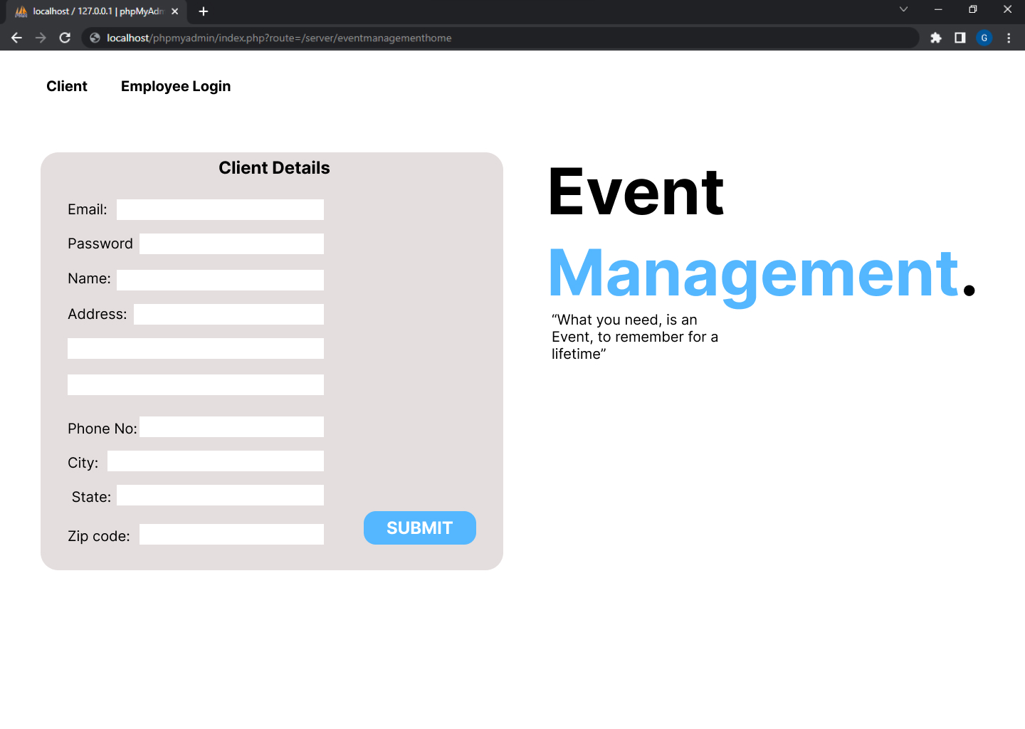

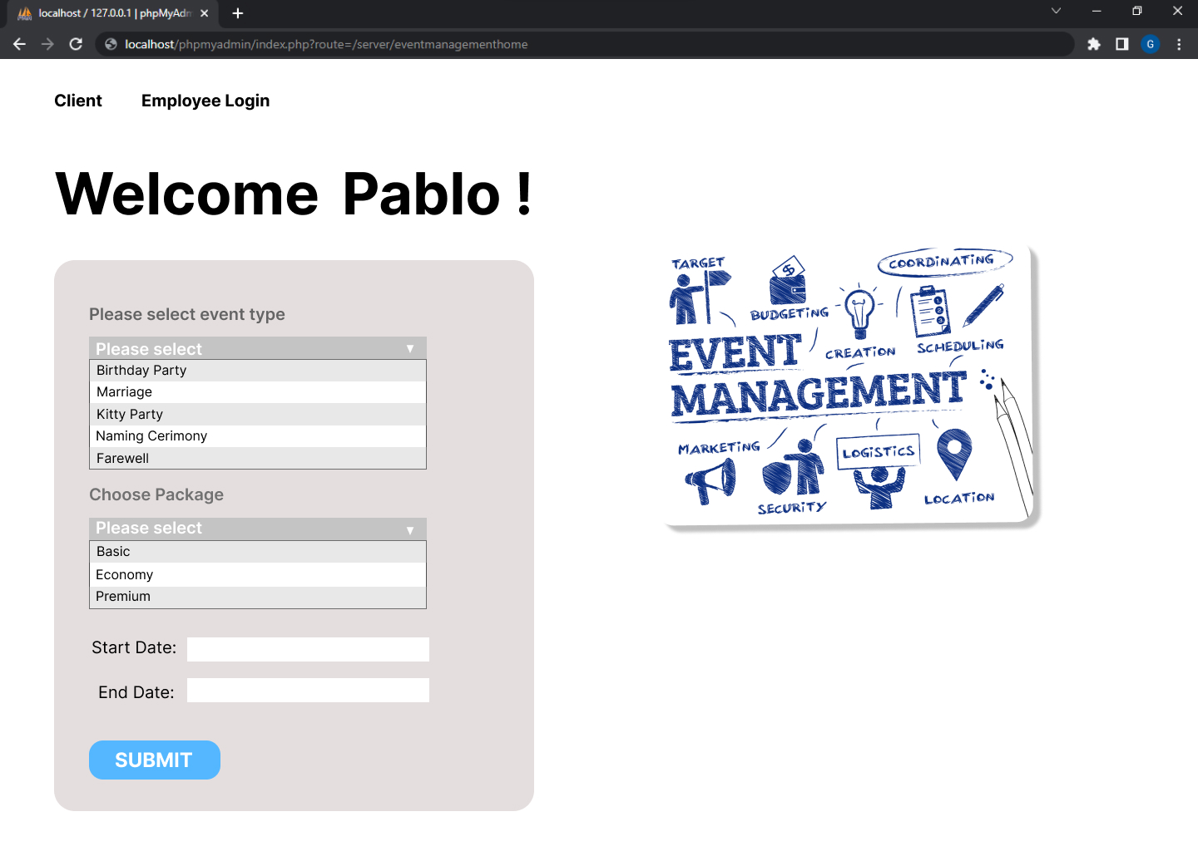

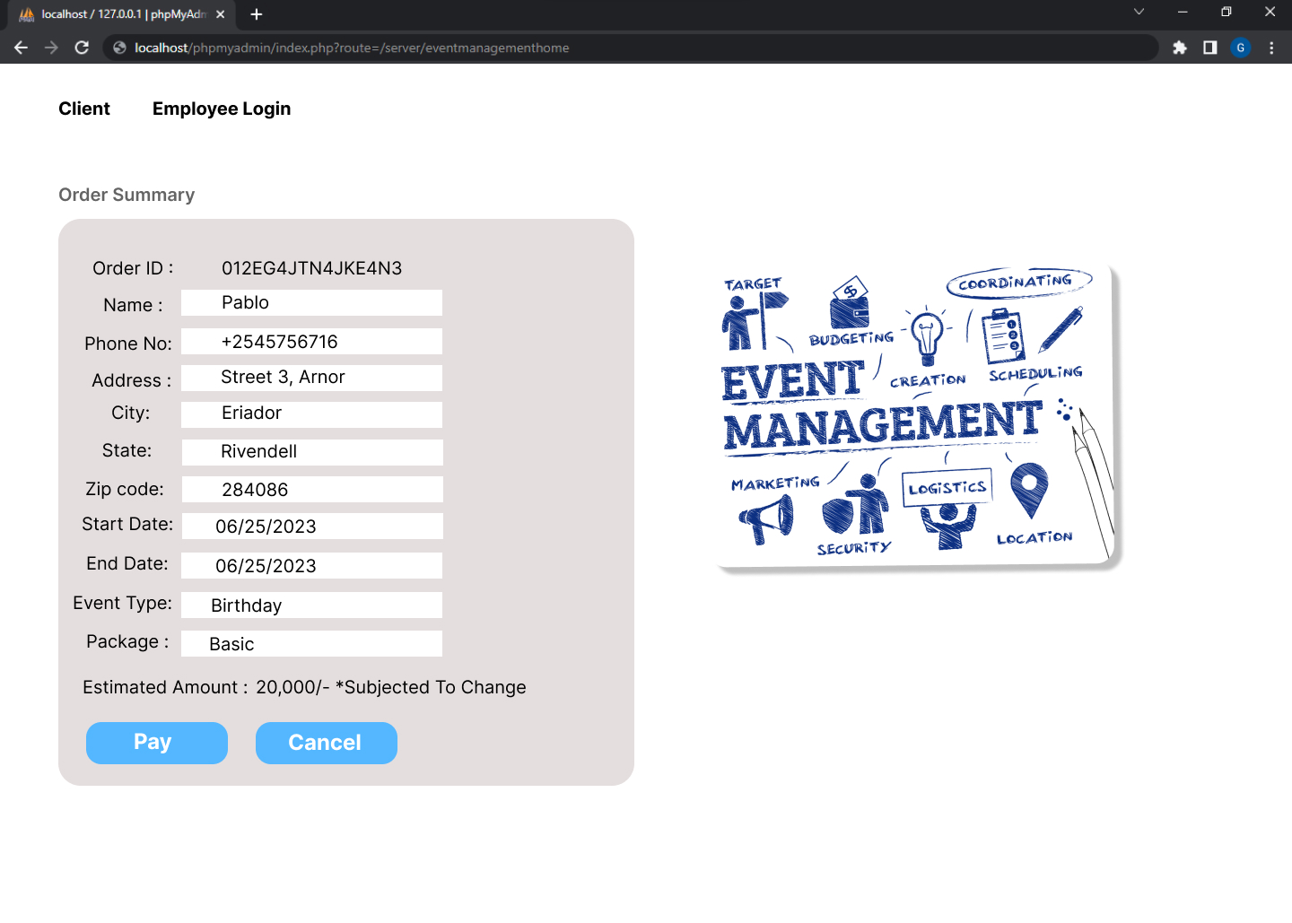

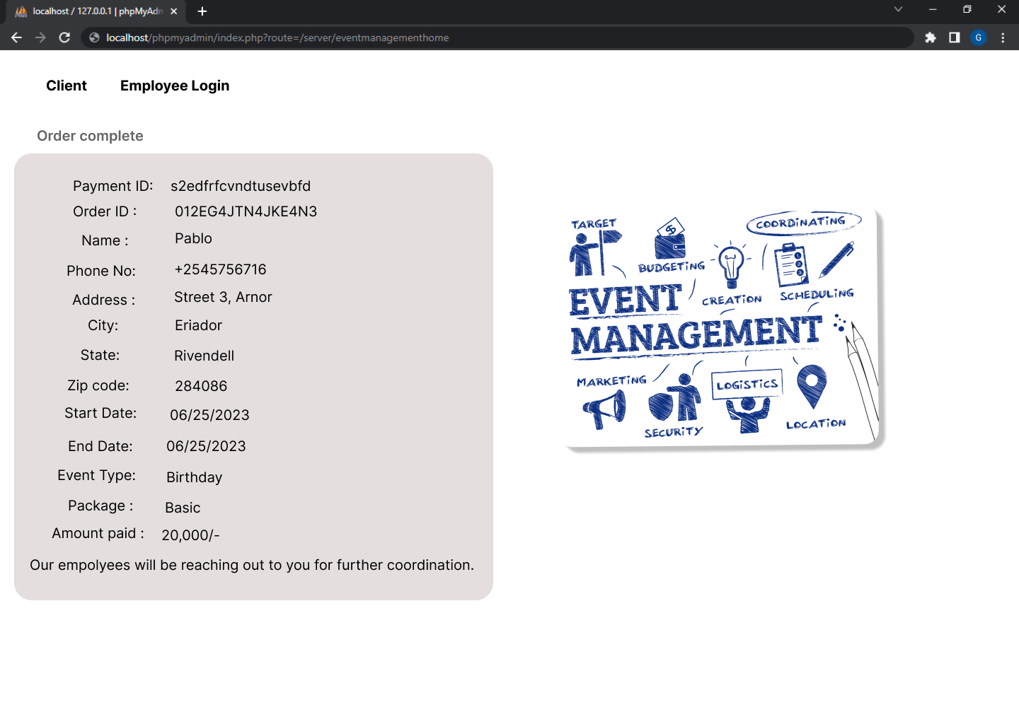

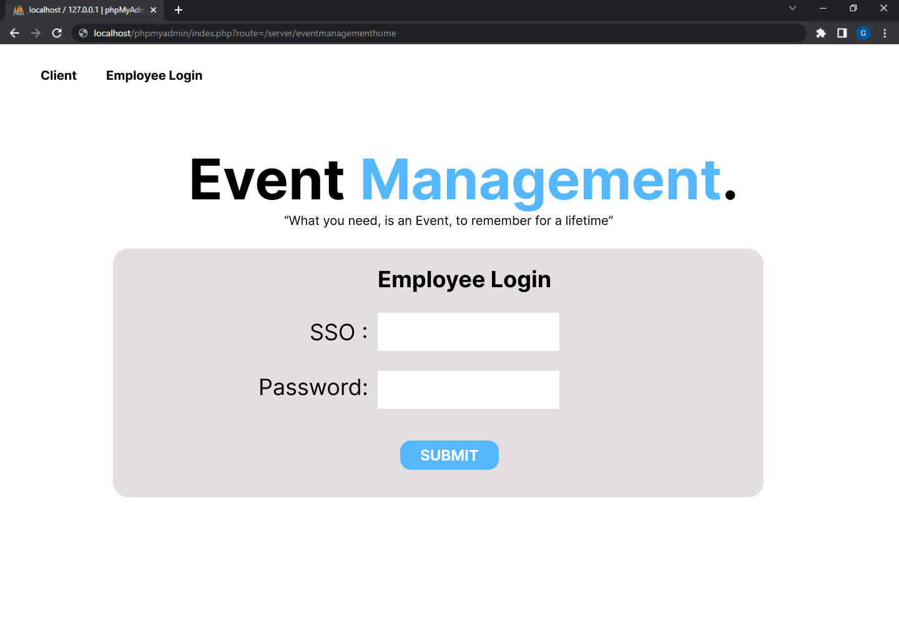

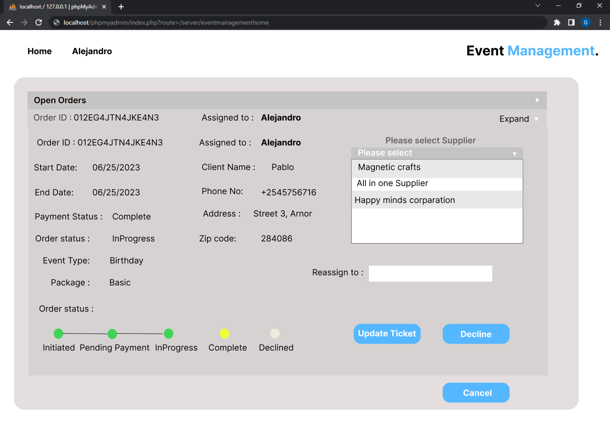

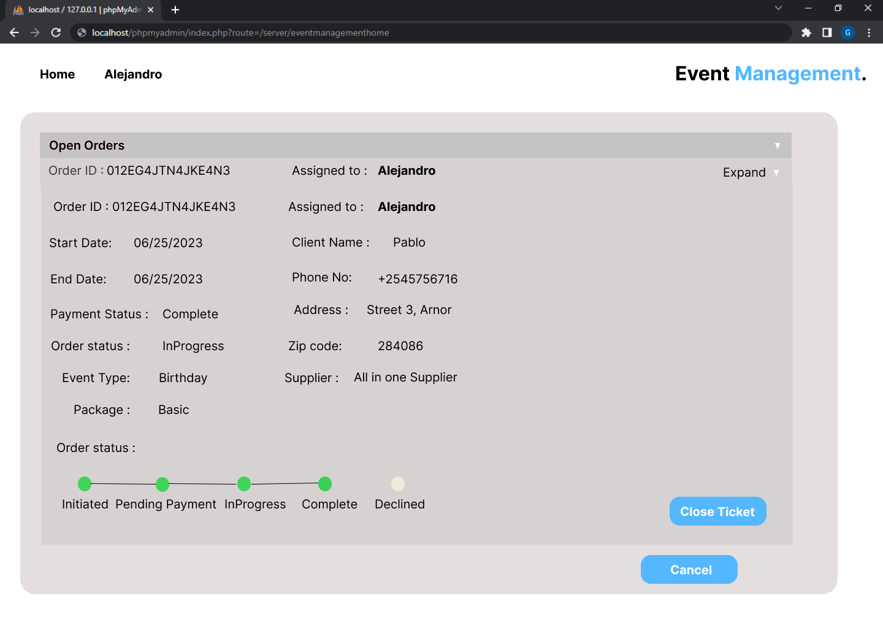

|  |  |  |  |
| --- | --- | --- | --- |
| **Version Number** | **Date** | **Author/Owner** | **Description of Change** |
| V1 | 10-04-2022 | Hannah | Initial Draft |
| V2 | 18/04/2022 | Karthik Gummadidala | RM and screenshots update |